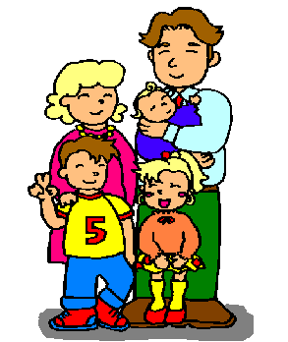

family
(famyli)

mum
(mam)

dad
(ded)

brother
(brader)

sister
(syster)

baby
bejbi

